Sustainable Cities for People
Sustainable City of Rustavi – Capacity Building of Rustavi Innovation Hub
Applying Behavioral Insights for Responsible Consumption of Plastic

(Draft evaluation report of the results of the project)

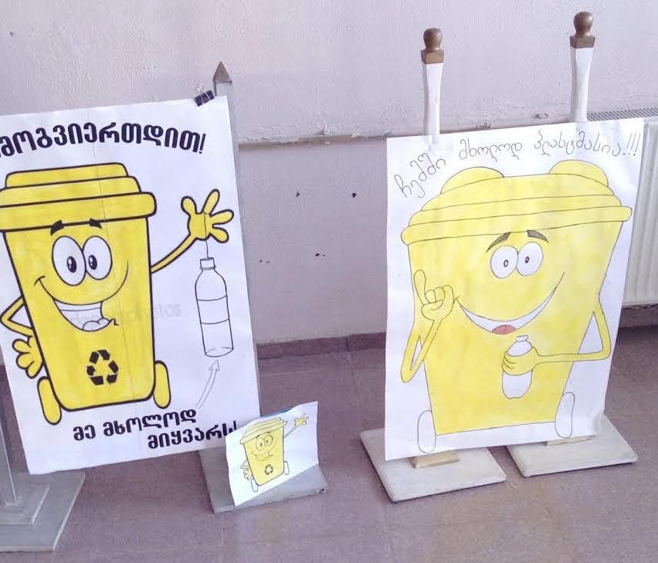

Kakhaber Bakhtadze
November 2020

Content
Introduction 3
1. Project background, objectives and deliverables 4
1.1 Project background 4
1.2 Project aim and objectives of the evaluation target activity 4
1.3 Expected deliverables 5
2 Need for evaluation, objective, and methodology 5
2.1 Need for evaluation 5
2.2 Aim of the evaluation 5
2.3 Methodology 6
3 Findings 8
3.1 Relevance 8
3.2 Efficacy 11
3.3 Effectiveness 13
3.4 Impact 13
3.5 Sustainability 14
4 Conclusions 16
5 Recommendations 16
Annexes 17
Annex 1: Memorandum of Partnership with Ltd Sanitari 18
Annex 2: Waste Management scheme (Infographics) developed in the scope of the project 20
Annex 3: Project Medium site link 21
Annex 4: Contact details of interviewed schools and kindergartens administrations 21
Annex 5: Contact detail of Rustavi infrastructure company manager 21
Annex 6: Contact details of project partner private companies 21
Annex 7: Links of project media materials 21

Introduction
Presented document is a final evaluation report of the project “Sustainable City of Rustavi – Capacity Building of Rustavi Innovation Hub” activity 3.2 - Moldova and Georgia working together in the application of the behavioral approaches to positively change consumer behavior in Georgia, and Rustavi in particular, supported by the United Nations Development Programme in the scope of the project “Sustainable Cities for People”. The project started in September 10, 2019, with duration of 12 months. It should be noted that project duration was extended due to COVID 19 pandemic for 3 more months.
The project evaluation has been implemented in several stages:
During the first stage of the evaluation the project documents were reviewed (project proposal, interim reports carried out during the project) and analysed.
On the second stage, the comparative analysis of the waste management strategy, action plan of the Government of Georgia and waste management plan for the Rusavi City in relation to the target project took place. The special attention was paid to the assessment of how activities of the implemented project contributed to the promotion of sustainable waste management practices reflected in the Waste Management Code of Georgia.
The third stage of the project has assessed the accordance of implemented activities with the approved deliverables of the project. Using co-participation approach, the information about successful examples of project activities and hindrance circumstances were found and analyzed, mainly from the project management team, beneficiaries and external stakeholders.
At the fourth stage of the assessment, the sustainability analysis of the implemented projects was carried out, based on the assessment of benefits of results for similar projects. Recommendations for social and economic sustainability of the project were developed based on the obtained findings.
The structure of the assessment report consists of four parts: the first chapter provides an information about the project, its objectives, tasks, target areas, planned activities and expected results. The second chapter describes a methodology of the assessment, which was used for preparing the report. The third chapter represents assessment findings, based on the technical tasks. The final, fourth chapter of the assessment provides conclusions and recommendations of socio-economic sustainability.
Generally, the report shows that the project responds to local needs and development trends in Rustavi city. Preliminary results by Rustavi Innovation Hub were achieved using effective approaches and the impact was assessed as "substantially positive" both on local and national levels. Project partners have been able to start new initiatives in waste separation based on received knowledge and developed capabilities.

- Project background, objectives and deliverables

Project background
The main determiner of the waste management policy in Georgia is the law “Waste Management Code” adopted by the Georgian parliament on December 26, 2014. The purpose of the Law is to provide legal conditions for implementation of measures aiming at prevention of generation of waste and increased re-use, environmentally-sound treatment of waste (including recycling and extraction of secondary raw materials, energy recovery from waste, as well as safe disposal). The objective of the Law is to protect the environment and human health: 1) by preventing and reducing the adverse impacts of the generation of waste; 2) by introducing effective mechanisms of management of waste; 3) by reducing damage caused by resource use and improving the efficiency of such use. Components of principles of the Waste Management Code are in full compliance with the “Directive on Waste of European Parliament 19/11/2008 and European Commission 2008/98/EC”.
The government of Georgia according to the requirements of the directives under the “Association Agreement” and the Waste Management Code developed and approved waste management 2016–2030 national strategy and 2016-2020 national action plan. The objective of the strategy is to harmonize the waste management process of Georgia with European waste management policy. The strategy covers 15-year period (2016–2030), and the action plan 2016–2020 period. The action plan will be elaborated in every 5 years.
The waste management vision according to the waste management national strategy is the following - “Georgia strives to become the country which is concentrated on waste prevention and recycling”.
In order this vision to be introduced in practice, 9 objectives were set in the national strategy of 2016–2030:
- Development, implementation, and execution of waste management legislation relevant to the requirements of the EU and international conventions;
- Formation of waste planning system on national and local levels;
- Formation of an effective system of waste collection and transportation;
- Provision of waste safe disposal;
- Waste prevention, reuse, recycling or/and restoration;
- Cost reimbursement of waste management based on the “ Pollutant Pays” principle;
- Support of extended producer responsibility;
- Establishment of waste data and information management system;
- Strengthening of public sector abilities on national and local levels, also support of strengthening of private companies’ abilities and raising of public awareness.
According to the Waste Management Code of Georgia, Rustavi city developed a 5-year waste management plan in 2017 covering period of 2018-2022. The Management plan outlines 9 objective and one of it targets establishment of waste separation system in the Rustavi city.

Project aim and objectives of the evaluation target activity
The project “Sustainable City of Rustavi – Capacity Building of Rustavi Innovation Hub” aimed to increase the knowledge and capacity of a team of civil servants and platform of actors in new participatory practices, models of engagement and evidence-based decision making, as well as evaluation of the new approaches for building solutions for persistent urban problems;
The objectives of the activity 3.2 “Moldova and Georgia working together in the application of the behavioral approaches to positively change consumer behavior in Georgia, and Rustavi in particular, plastic consumption behavior and related waste management practices” were as follows:
1) To raise awareness of the city population in terms of waste management; 2) identify actors needed to successful implementation of the process and build a value chain with their involvement; 3) develop a complete process design through an intersectoral cooperation.
It was also important to determine the economic viability of the process and its subsequent commercialization and outsourcing. It was important to define the target group of the pilot cycle, which would maximize its effectiveness and comply with waste management plan of the Rustavi city. That was why public schools and municipal kindergartens were selected for participation in the project.

Expected deliverables
Project implementation was divided based on 6 deliverables:
  - Develop a plastic bottle collection cycle by engaging private and education institution network;
  - Formalise partnerships between public-private sector;
  - Develop a monitoring framework on the pilot and data collection methodology;
  - Based on the results, create behaviourally informed interventions targeting both reduced plastic consumption, as well as sustainable plastic waste management practices.
  - Produce a audio-video materials for wider public awareness raising;
  - Produce a case study for peer to peer learning exchange;
- Need for evaluation, objective, and methodology

Need for evaluation
Need for the project evaluation is based on goals that are associated with study of positive and negative impact of the development projects. Project evaluation helps parties involved to analyze results of planned intervention, and develop future development directions of the program/project, and/or recommendations for sustainability.

Aim of the evaluation
The aim of this evaluation is to:
- Study efficacy, effectiveness, and relevance of project management approaches, based on results achieved.
- Develop findings, conclusions and recommendations for the sustainability of project results, which can be used by the local partner, working in the field of waste management in the city (Rustavservice Center).
6 main criteria were used for evaluation of project activities, and answers were provided to the following questions:
Relevance
- How justified is what we do in relation to the strategic plans of the national level (namely, whether the target project responds to the waste management strategy of Georgia government (2016-2030) and action plan (2016-2020)?
- How important is what we do in relation to the local needs and priorities (e.g. whether project activities respond to the local needs and how compatible the service, delivered within the project, is with local waste management plan)?
Efficacy
- How can we compare planned activities to the obtained results? Have set out tasks, for the given time period, been achieved (are obtained activities relevant to the action plan, approved by the project)?
- In what cases could interventions, planned to achieve project objectives, not be implemented? What were the results of those major problems, related to the achievement of project like plastic waste separation and processing?
- Were all target groups involved?
Effectiveness
- What progress was shown by the implementation of the project in the waste management system of Rustavi city and awareness rising of local communities?
- Were held consultations, trainings and information campaigns effective?
Impact
- How many people were affected by the project results in target schools and kindergartens?
- How satisfied are project beneficiaries with the service provided by the project and material support?
Sustainability
- Are the project results sustainable?
- How can project activities, results and effectiveness be developed after the donor assistance/interference (what are recommendations for social and economic sustainability of the project)?

Methodology
Project evaluation methodology combines qualitative and quantitative methods and consists of the following steps:
- Introduction and discussions
- Desk review
- Consultation meetings with project beneficiaries both on local as well as national level
- Triangulation
- Preparing draft report and submission to the client
- Finalization of the report.
Below we provide details on main steps that were of key importance to evaluation of project results.
Introduction and discussions
Beneficiary groups of the project were quite large, and covered almost all parties of Rustavi population as the project targeted all schools and kindergartens in the city. In order to ensure multifaceted evaluation of the project results, the consultant interviewed schools and kindergartens representatives (directors and administrators) as well as employees of private recycling companies and local government. To assess compliance with overall project development goals, preliminary meetings were held with the Representative of the UNDP Ms. Khatuna Sandroshvili and head of the board of Rustavi Innovation Hub Mr. Revaz Barbakadze.
Desk Review
Following documents were studied and discussed during desk review:
- Project planning documents (project proposal);
- Project technical report;
- Waste Management Code of Georgia;
- Waste Management Strategy of Georgia 2016-2030;
- Waste Management Action Plan of Georgia 2016-2020;
- Rustavi city Waste Management Plan 2018-2022;
- Studies and assessments;
- Educational publications and technical manuals;
- Media publications and materials
Consultation meetings with project beneficiaries both on regional as well as national level Due to COVID 19 pandemic situation in the country the consultant conducted phone and Skype calls with beneficiaries on local and central levels that have benefited from project intervention. In our case, these groups included directors of 3 public schools of Rustavi city and 3 administrators of the public kindergartens involved in the project, representative of Rustavi city waste management service and manager of Solid Waste Management Company of Georgia responsible for the operation of all landfills around the country including Rustavi municipal landfill. Consultations were held with owners and managers of private recycled waste collection, processing and production companies partnering with the project to develop recycled waste separation and processing chain.
Triangulation
Given approach was used to verify project information with other sources, to assess project results based on information provided by project team, beneficiaries, outsider observers as well as based on document records and reports prepared.
Preparing draft report and submission to the client
The results of the preliminary report, prepared by the project evaluation consultant, were presented to Rustavi Innovation Hub. During the meeting, evaluation circle and questions arrived in the process of documents revision as well as discussions with project beneficiaries and partners were discussed and analyzed.
Finalization of the report
Report finalization phase included final analysis of all information gathered, development of thematic recommendations, and validation of such recommendations with project management team, beneficiaries, and partners. Final report, provided to the Client, also incorporated comments received during the process.

- Findings

Relevance
Relevance is an important component of project justification and answers questions like:
- How justified is what we do in relation to strategic plans of the national level (namely, if target project responds to the Waste Management Strategy of the Government of Georgia (2016-2030) and Action Plan (2016-2020)?
- How important is what we do in relation to local needs and priorities (e.g. whether project activities respond to the local needs and how compatible the service, delivered within the project, is with local waste management plan)?
As comparative analysis of the document of the Waste Management Strategy and project "Sustainable City of Rustavi – Capacity Building of Rustavi Innovation Hub" shows, how the project objectives reflect the waste management strategic directions defined by the government and consider a large part of measures detailed in it (see Table 5), namely:
Table 1: Comparative analysis between strategic directions of the Waste Management Strategy of Georgia and the activities implemented within the project
Goals of the Waste Management Strategy (2016-2030) | Objectives and Indicators of the Waste Management strategy of Georgia | The relevant actions implemented within the project "Sustainable City of Rustavi – Capacity Building of Rustavi Innovation Hub"
Objective 5: Waste prevented, reused, recycled and/or recovered to the extent possible | Objective 5.2 Minimum amount of plastic recycling by 2020 is 30% | Within the project plastic recycling was initiated in all public schools and kindergartens of Rustavi City. Collected plastic resource was delivered to processing factory located in the Rustavi city.
Objective 9: Capacities strengthened for the national and local public sector, as well as private companies and general public to meet the requirements of the development of the WM system | Objective 9.2 of municipal staff capacity in waste management by 2020 is developed | In the scope of the project recyclable waste separation, collection, transportation and processing model was developed in close cooperation with municipal authorities. Developed and piloted model was used by the municipality to reach targets set by Waste Management Strategy of Georgia
 | Objective 9.3 capacity of private companies in waste management by 2020 is developed | The project established strong cooperation with private companies involved in waste collection and processing. Based on Rustavi project experience Ltd Sanitari partnering the project in separated waste collection in Rustavi was engaged in similar activity in Tbilisi from November 2020.
 | Objective 9.4 awareness raising of public around waste management by 2030 | In the scope of the project awareness raising campaigns were organized in all public schools and kindergartens in Rustavi city.
The purpose and objectives of the project are in line with the waste management Action Plan of Georgia 20216-2020, which is the main directing document for national and local government for planning and implementations of waste management activities.
Table 2: Comparative analysis between directions and measures of the Waste Management Action Plan of Georgia 2016-2020 and the activities implemented within the project
Objective of the Waste Management Strategy | Objective of the Waste Management Action Plan | Relevant activities implemented within the project
Objective 5.2 Minimum amount of plastic recycling by 2020 is 30% | Objective 5.2.1: Establishment of alcoholic and non-alcoholic drink bottle collection system  The action plan highlights importance of donor and private organizations support in the activity | In the scope of the project plastic recyclables were collected and processed mainly focusing of plastic bottles used for non-alcoholic drinks.
Objective 9.2 of municipal staff capacity in waste management by 2020 is developed | Objective 9.2.1: Needs assessment of local municipalities and elaboration of action plan related to waste management | In the scope of the project local practice of waste management was studied and model for recyclable waste management developed. The model was transferred into easy understandable scheme and distributed among public servants and local population.
Objective 9.3 capacity of private companies in waste management by 2020 is developed | Objective 9.3.2: Piloting of waste management successful model in private companies | The project actively cooperated with the private companies active in the field of waste management collection, transportation and processing. The partnership crated the full cycle recyclable waste management model applicable for other private companies and municipalities of Georgia.
Objective 9.4 awareness raising of public around waste management by 2030 | Objective 9.4.1: elaboration and implementation of public awareness raising campaigns on waste management topics | The project worked in all school and kindergartens in one of the largest city of Georgia and implemented public campaign involving teachers, kids and their family members.
The Waste Management Strategy and Action Plan provided basis for the elaboration of the Rustavi city waste management plan, which was approved by municipal council in 2018 and will guide the waste management activities in the city till 2022. The goal of the waste management plan is to improve waste management practice in Rustavi municipality in compliance with Waste Management Strategy (2016-20230) and Action Plan (2016-2020) of Georgia project activities contributed to implementation of city targets related to set up of recyclable waste management system.
Table 3: Comparative analysis between Rustavi city Waste Management n Plan 2018-2022 and the activities implemented within the project
Objective of the Waste Management Plan | Planned activity to reach the set objective | Relevant activities implemented within the project
Objective 4: Set up of waste separation system in Rustavi municipality | Activity 4.1: promotion of waste separation activities in public institutions | In the scope of the project separation recyclables were promoted in all public schools and kindergartens of Rustavi city.
 | Activity 4.2: Set up of waste separation points for paper and plastic in public institutions and public gathering spaces | The project equipped all schools and kindergartens of the Rustavi city with waste separation containers and provided with knowledge on waste separation to specially appointed personals responsible for separated waste collection.
 | Activity 4.3: communication and partnership with private companies involved in recyclable waste separation, transportation and processing | The project identified and partnered with 3 national companies working in the field of waste recycling. All 3 companies participated in the project and contributed to transportation and processing of the waste.
Objective 6: Awareness raising of Rustavi municipality population | Activity 6.1: Implementation of information- cognitive activities for local population | In the scope of cooperation with local schools and kindergartens the project covered almost all representatives of the Rustavi city population. Information and Knowledge delivered to kids were transferred to parents and involved them in project initiated plastic waste separation activities.
Objective 9: Development of Public Private Partnership | Activity 9.2: Partnership with private companies involved in recyclable waste management | The project team set a successful partnership with private companies working in the field of waste management. Official memorandum on cooperation was signed with Ltd Sanitari and the company assisted the project in waste collection and transportation to waste processing factory
As project relevance analysis demonstrates the project planned and implemented activities are in compliance with national and local priorities related to recyclable waste management. The project has contributed to the establishment as well as piloting of the waste separation and processing model for one of largest city in Georgia covering all public schools and kindergartens. The project enabled stimulation of public private partnership in the field, which was replicated in the Capital of Georgia Tbilisi from November 2020.

Efficacy
To evaluate efficacy of the project, we determine whether objectives of the project were achieved through activities planned, and answer the following questions:
- How can we compare planned activities to the obtained results? Have set out tasks, for the given time period, been achieved (are obtained activities relevant to the action plan, approved by the project)?
The theory of change of the project was based on the deliverables defined in the project proposal under the project activity targeting behavior of Rustavi city population related to plastic waste management. 6 deliverables were identified in the document targeting 1) Development of plastic bottle collection cycle by engaging private and education institution network; 2) Formalization of partnerships between public-private sector; 3) development of monitoring framework on the pilot and data collection methodology; 4) Based on the results, creation of behaviourally informed interventions targeting both reduced plastic consumption, as well as sustainable plastic waste management practices. 5) Production of audio-video materials for wider public awareness raising; 6) Production of a case study for peer to peer learning exchange;
The project team has successfully produced most of set deliverables. Rustavi is the first city in Georgia, which was capable to develop plastic bottle collection cycle in all public schools and kindergartens. Three private companies were motivated and involved in the cycle distributing responsibilities for collection and transportation (Ltd Sanitari), preliminary processing (Ltd Clean World) and recovery of the plastic resource (Ltd Caucaspack). The plastic bottle collection and processing cycle developed in the project can be successfully replicated in other municipalities of Georgia working on recyclable waste management. In the scope of the project partnership memorandum of partnership (Annex 1) was signed with the Ltd Sanitari. The company took responsibility for the transportation of collected plastic bottles to the preliminary processing facility for free during the first 3 months of the implementation of activity, after 3 months project financed only technical costs for the collection activity covering fuel and salary costs of waste truck technical workers. Based on experience gained in Rustavi city Ltd Sanitary signed memorandum with Tbilisi city to start similar activities with larger scale (collection and transportation of paper, glass and plastic waste from 24 pilot recyclable waste collection centres). The project team initiated development of mobile application for the calculation of collected waste in waste separation bins. The process was interrupted due to COVID 19 crisis in the country and closure of all educational institutions around the country. The project team has built based on results of the project the simple understandable scheme for waste separation and collection. The scheme was published as infographics poster (Annex 2) and distributed in public institutions as well as public gathering places. Public outreach was important activity for the project. The project team developed thematic page on Medium web-site and delivered information/story about the project. This was a innovative approach of storytelling about the project using modern platform for information sharing attracting local youth groups (Annex 3). To develop project case study as it was identified in the deliverable 6 of the proposal and reduce expenditure of project financial resources, the project team decided to utilize project evaluation report and asked evaluation consultants to apply story-telling approach in the document.
- Were all target groups involved?
The project targeted all public schools and kindergartens in Rustavi city. This approached guaranteed involvement of all groups of city population in the plastic bottle waste separation and collection activity. As it was identified during the discussions with school and kindergarten administrations around 65-70% of school and kindergarten kids and their families participated in the activity. Government of the Rustavi city was also actively involved in the process participating in school campaigns and opening ceremonies on new collection points around the city. After the initiation of the project the project team identified and partnered with private companies covering full cycle of the waste recycling process and involving them in project activities targeting corporate social responsibility as well as benefit related to access on new resource source.
- In what cases could interventions, planned to achieve project objectives, not be implemented? What were the results of those major problems, related to the achievement of the activity like plastic waste separation and processing?
Main obstacle for the project implementation process was the COVID 19 pandemic. All project activities related to waste separation and transportation were suspended due to regulations introduced by the government of Georgia covering educational as well as waste collection systems. From the end of March 2020 all educational institutions were closed and waste separation containers stored before restrictions will be removed.

Effectiveness
Effectiveness is an important component of the project justification and answers such questions as:
- What progress was shown by the implementation of the project in the waste management system of Rustavi city and awareness rising of local communities?
The analysis of the information and data obtained through the assessment shows that the project was important step forward towards waste separation and recycling in the Rustavi city and contributed fulfilment of objectives identified in the waste management plan of Rustavi municipality. The project was able in limited time period organize and train all public schools and kindergartens administrations in setup and running of plastic waste separation points. Important part of the process was related to organization of separated was transportation and processing. As result of successful planning the project team identified and partnered with private companies interested and ready for partnership in the process. After 6 month of the project initiation the full circle of recyclable waste management was developed, tested and operated around of one of the largest city in Georgia with 126,000 population. It has to be highlighted that Rustavi city is industrial centre of Georgia from the Soviet era and large industries are located in the city borders. It was first initiative in the city targeting waste separation and due to targeted awareness raising camping in school and kindergartens with teachers, administrations, kids and parents around 65-70 % of kids and their families participated in the process and after the closure of educational institutions in Georgia all administrations involved in the process expressed their reediness for partnership and continuation of the activity.
- Were held consultations, trainings and information campaigns effective?
During the initial phase of the project thematic consultations were held with all 28 public schools and 43 kindergartens administrations. The project team was able to convince and engage all administrations in the waste separated collection initiative. After the agreement with school administrations thematic trainings were organized for teachers to provide them with needed knowledge on home based plastic separation and collection in public spaces. Based on the trainings one person was allocated in all involved institutions to manage the process. After establishment of school separation collection system information and awareness raising campaign was initiated in schools focusing on impact of plastic waste pollution and existing technics of waste separation, collection and processing. During the elaboration of the evaluation report the evaluation consultant held 6 meetings with representatives of 3 public schools and 3 kindergartens administrations. Ms. Ekaterine Melkadze, Director of 16 public school of Rustavi highlighted that 602 kids are studying in the school and around 380-400 of them (mainly from 1 to 9 grade) were actively involved in the plastic waste separation process. Ms. Leila Giorgadze, Administrator of 1st kindergarten in Rutavi city has informed the evaluator that 240 kids and their families participated in the separated waste collection initiative out of 270 registered in the kindergarten.

Impact
Project evaluation process should look at the impact on beneficiaries that directly benefited from project activities. For this, the consultant processed existing materials and analysed data on benefit received. Information gathered from Rustavi Innovation Hub and local beneficiaries show that beneficiaries could be divided into three groups. First group brings together local population involved in the process of separated waste collection. Second group Rustavi city government responsible based on Waste Management Code of Georgia and Rustavi municipality Waste Management Plan on initiation of waste separation activities in the city and targeting collection of 30% of plastic waste in the process till 2021. Third beneficiary group for the project was business, 3 private companies involved on waste collection, transportation and processing. As a result of assessment, the following question was answered:
- How many people in Rustavi city were affected by the project?
Activities of the project directly affected up to 28 public schools (21,737 kids) and 22 kindergartens (5,603 kids) around the Rustavi. Based on average percentage provided by schools and kindergartens administration about participation in the campaign, number of population involved in the campaign was calculated. As it was highlighted in the evaluation report, around 55% kids and families of public schools and kindergartens were involved in the waste separation activities. Based on this information and assumption that each kid has 2 members in the family we can calculate approximately number of Rustavi municipality population participated in the campaign and it will be 45,111 people which is 1/3 of all population.
- How satisfied are project beneficiaries with the service provided by the project support?
In the scope of the project two main beneficiary groups were identified. One is population of Rustavi city generally benefiting from the improved environmental conditions and second group id the government of Rustavi municipality responsible for the waste management in the area. The activities implemented within the project were directed towards improvement of the waste management system in Rustavi city, which is industrial centre of Georgia. Environmental pollution is one of the key issues for local population and they are open for cooperation and partnership in new initiatives directed towards environmental protection. During the interviews with representatives of schools and kindergartens (Annex 4) high interest was retrieved from schoolteachers, kids and their families. Average participation in all educational institutions involved in the project was 55% and in some cases it reached 95%. Another important beneficiary of the project was government of Rustavi municipality. In 2018 the municipality approved waste management plan for the city and identified separation of plastic waste as one of the targets for 2020. As the evaluation process has demonstrated fulfilment of the obligation was directly linked with the project and no other activities were implemented for the target taken under the waste management plan. Interviewed manager (Annex 5) of the infrastructural activities in the city highly valued the work of the project and expressed their readiness for the up scaling and continuous support of the initiate.

Sustainability
Ensuring sustainability of project results is a precondition of its long-term success, so the issue of sustainability is of big importance in evaluation report. The following questions are asked while assessing sustainability of the project:
- Are project results sustainable?
- How possible is it to develop project activities, results and effectiveness after donor assistance/interference is over (what are the recommendations for social and economic sustainability of the project)?
- Was there any cooperation with other stakeholders within the project?
As project intervention logic shows, Rustavi Innovation Hub from the very beginning took into consideration challenges that could be associated with project sustainability. The project activity idea was fully inline with the waste management code of Georgia strategy and action plan. The activity directly contributed towards the Rustavi municipality waste management plan target for 2020 and was inline with local development priority aiming reaching of 30% of plastic waste collection. In the scope of the project full chain scheme for the recyclable waste management was developed, agreed with local government, participating educational institutions and private companies (Annex 6) engaged in separated waste collection and processing with whom thematic memorandums were signed. To enable technical compliance of the involved institutions with developed waste separation scheme the project purchased and handed over containers for separation waste collection. To summarise findings related to sustainability, the success reached during the limited period of the project has to be highlighted, which is the complete model (included planning and implementation) for plastic waste separation, collection, transportation and processing. The model is operational and the Rustavi municipal authorities can easily continue it as well as share to other municipalities interested with local experience on plastic waste management.
Working with Media:
Local media frequently covered the project activities (Annex 7). Information about the project was published on the Rustavi municipality and Rustavi Innovation Hub Facebook and web pages. The Project team used Medium platform to provide information in storytelling manner about the project to wider audience interested in sustainable waste management and ways for public private participation in the field.
- Conclusions
Activities implemented and results show that:
- The Project deliverables were in compliance with Waste Management Strategy and Action Plan of Georgia and contributed to fulfilment of Waste Management Plan of Rustavi Municipality targets for 2020 related to plastic waste separated collection.
- The Project team applied successful strategy for mobilization and engagement of local schools and kindergartens administrations, teachers, kids and parents in plastic waste separation and separated collection in public spaces.
- Government of Rustavi municipality was actively supporting the project and participating in opening ceremonies of separated waste collection points in public schools and kindergartens.
- High percentage of school (around 50-55%) and kindergarten (75-80%) kids and families were involved in the waste separation and collection campaign. Around 70-75 kg plastic bottle waste was collected per day in waste separation points.
- The project has established partnership with private companies involved in the recyclable waste collection, transportation and processing activities. Based on experience from Rustavi city plastic waste collection initiative Ltd. Sanitari signed contract with Tbilisi city hall on implementation of separated waste collection activities in the capital of Georgia.
- All educational institutions expressed readiness for continuation of plastic waste collection activities. All containers provided for plastic waste collection are kept in storage for the thematic use after the schools will open once the pandemic restrictions will be terminated.
- Recommendations
The assessor’s recommendations are related to the sustainability of the activities implemented within the project, which will help to strengthen and expand recyclable waste separation, collection and processing initiative.
- It is important to hand over developed model with all contacts and equipment to Rustavi municipality government and elaborate project results sustainability and extension plan based on Waste Management Plan of Rustavi municipality.
- Provide additional separated waste collection containers to schools and kindergartens to enable them collection of increased amount of separated plastic waste (school and kindergartens administrations have highlighted in interviews that interest in school kids and parents is increasing and they will need additional equipment to manage collected waste amount.
- Support separated waste collection activities by regular educational campaign around the Rustavi municipality and provide special prices for most active public institutions.
- Work with other municipalities in Kvemo Kartli region to assist them in replication of Rustavi city model of separated waste collection and processing. Extended initiative will raise business interest among private companies involved in recyclable waste management and ensure long-term sustainability of the model decreasing needed financial resources for its maintenance.
- Encourage business initiatives targeting waste separation and recycling by providing legislative and financial incentives as well as technological innovations from Rustavi municipality government in cooperation with Rustavi Innovation Hub.

Annexes
- Memorandum of Partnership with Ltd Sanitari
- Waste Management scheme (Infographics) developed in the scope of the project
- Project Medium site link
- Contact details of interviewed Schools and kindergartens administrations
- Contact detail of Rustavi infrastructure company manager
- Contact details of project partner private companies
- Links of project media materials

Annex 1: Memorandum of Partnership with Ltd Sanitari
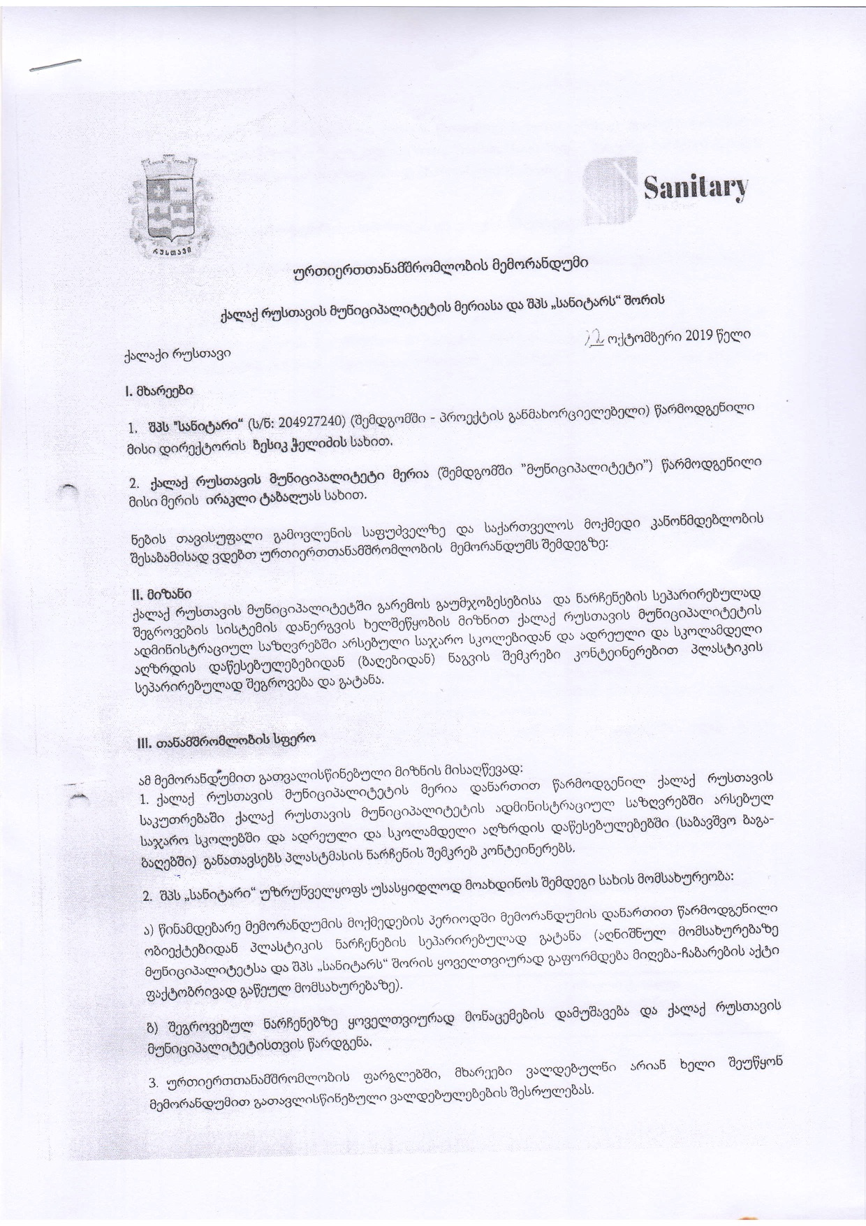
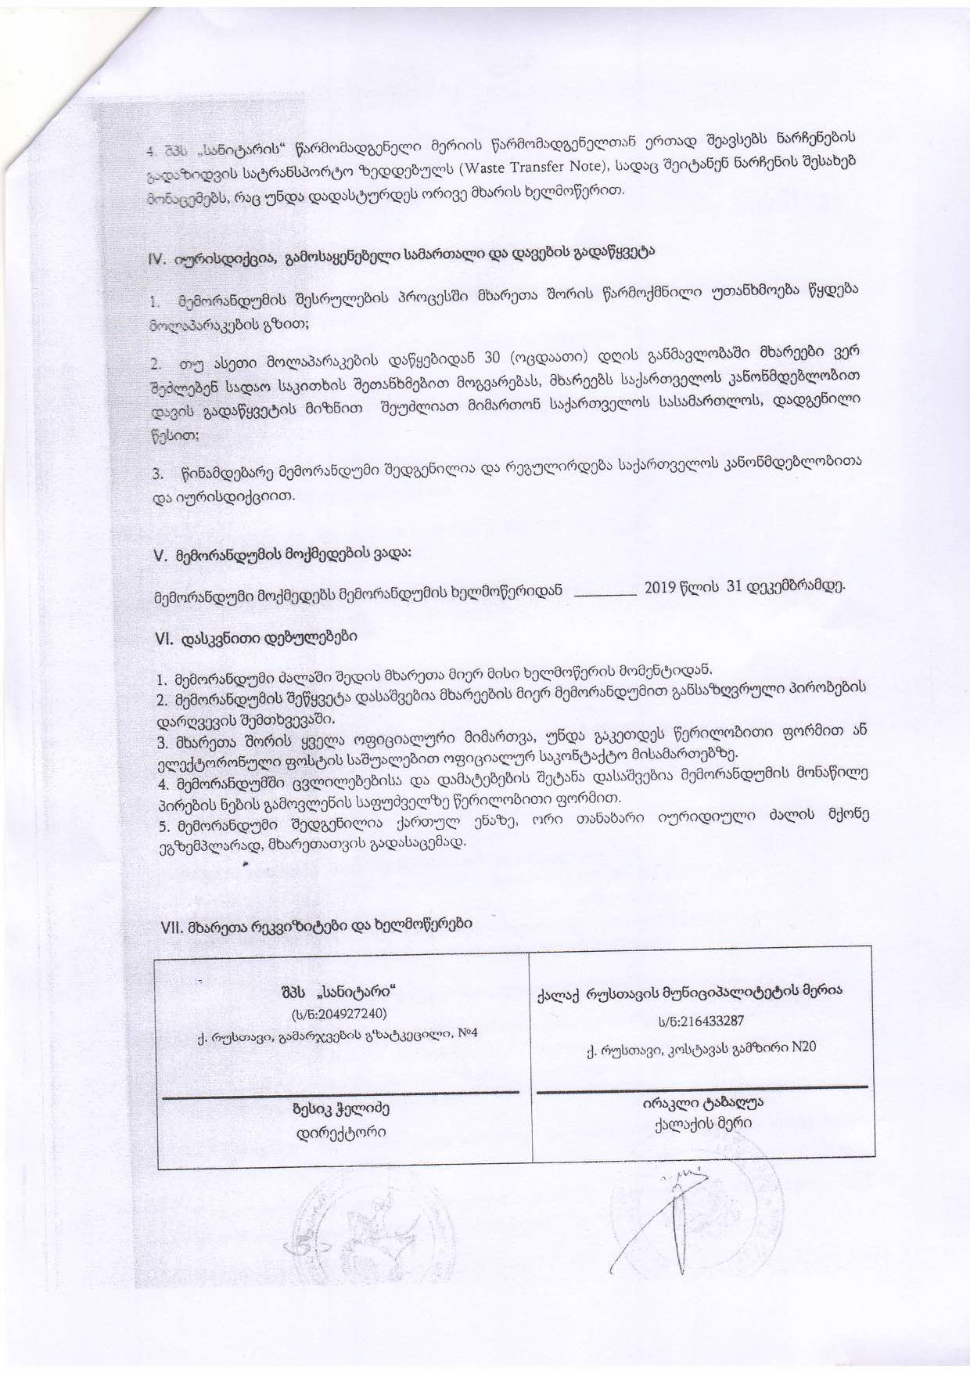

Annex 2: Waste Management scheme (Infographics) developed in the scope of the project
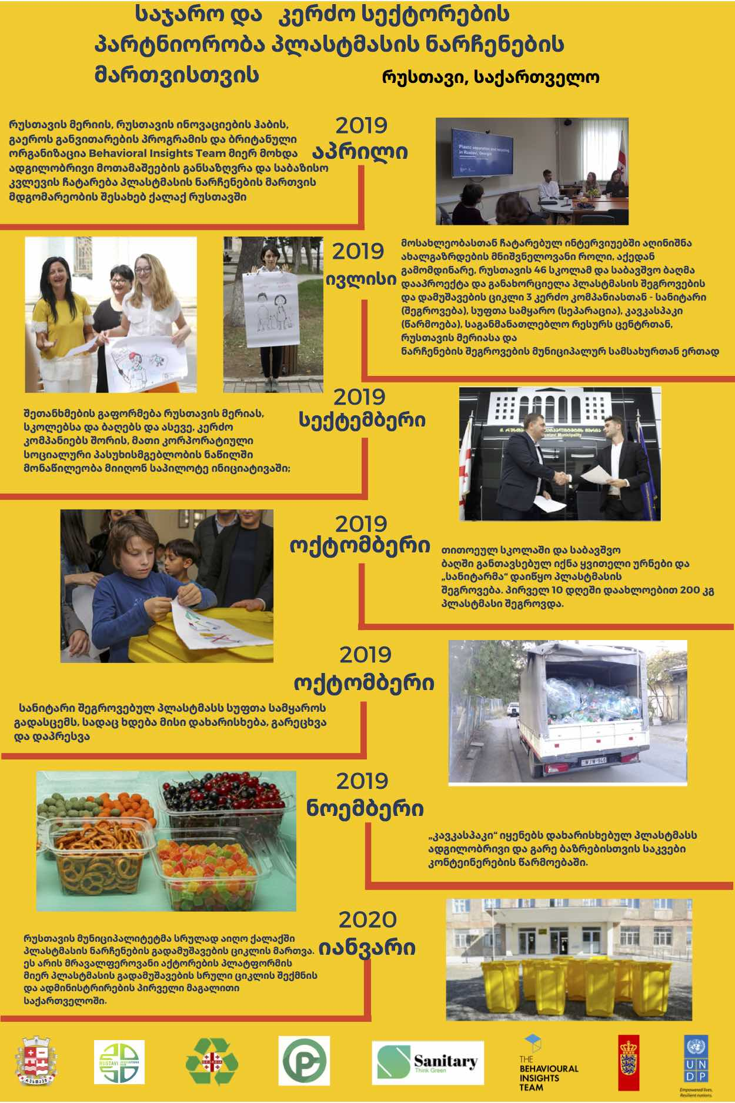

Annex 3: Project Medium site link
https://medium.com/@rustavi2050/ინტერ-სექტორული-თანამშრომლობა-ინოვაციებისთვის-5d5b683069bd
https://medium.com/@rustavi2050/inter-sectoral-cooperation-for-innovation-38fe1bb8174b

Annex 4: Contact details of interviewed schools and kindergartens administrations
Public school N4 - Mamuka Samkharadze, Director 577211417
Public school N22 – Eka Tskhvedadze, Director 577211422
Public school N16 – Irine Melkadze, Director 599417994
Kindergarten N 10 – Giorgi Bochorishvili, Administrator 588 88 74 47
Kindergarten N 27 – Tamar Alelishvili, Administrator 599 69 30 69
Kindergarten N 10 – Giorgi Bochorishvili, Administrator 593 32 36 42

Annex 5: Contact detail of Rustavi infrastructure company manager
Rustavservicecenter municipal Ltd – Badri Modebadze, Manager 599531464

Annex 6: Contact details of project partner private companies
Ltd Sanitari – Levan Kvirkvelia, Director 599 583031
Ltd Clean World - David Tskitishvili 551 690555
Ltd Caucaspack – Amiran Tsertsvadze 599 26 11 71

Annex 7: Links of project media materials
- http://servicelab.sda.gov.ge/events/რუსთავში-პლასტმასის-ნარჩ/?fbclid=IwAR11jV5TPjMTq-zhSNUJF3HPsnT7ltozF75sOOcrFNwgFo_8X1Dlu546wIw
- https://www.facebook.com/RustaviInnovatiionHub/posts/333435267535032
- https://inforustavi.ge/?m=31&cat_id=4&news_id=11928&fbclid=IwAR0Qor8Ud6tl1nLh-MuK3aFmnzJaqv7yQkHmidKvz2M_Ojq_Kmf-hdtDnIQ
- https://www.youtube.com/watch?v=c2GJcZKpxTc&t=4s&fbclid=IwAR29VB4mDsuAiAh8qgkjluEiTBZVuAkLp0CwXRxSUNYra1SfWlfc5tsSKdM&app=desktop
- https://fb.watch/1zRc4O8-PH/
- https://www.facebook.com/RustaviCityHall/photos/a.2437334313173480/2437334349840143
- https://www.facebook.com/khatuna.sandroshvili/posts/10218750453486116
- https://www.ge.undp.org/content/georgia/en/home/stories/recycling.html?fbclid=IwAR2TZMWLsJCariKrm9CfNYlxYMfsFu2oSBiFm_WHNvGa-wfmjiv071F0Zgc#.XcxoWiAjcII.facebook
- https://www.radiotavisupleba.ge/a/წელი-სამოქალაქო-აქტივიზმის-ნიშნით/30352997.html?fbclid=IwAR0pwM-SZl_AvjRN13TS6IcpXcfxc7Fkj0ezuFTuPKqBtz6FaVqUz_mpuxM

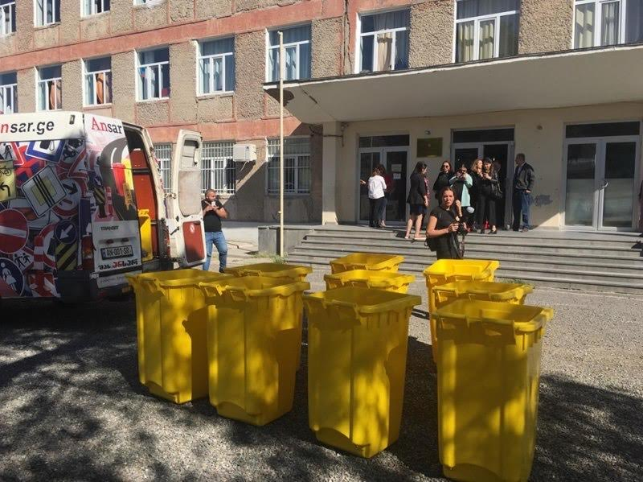 | 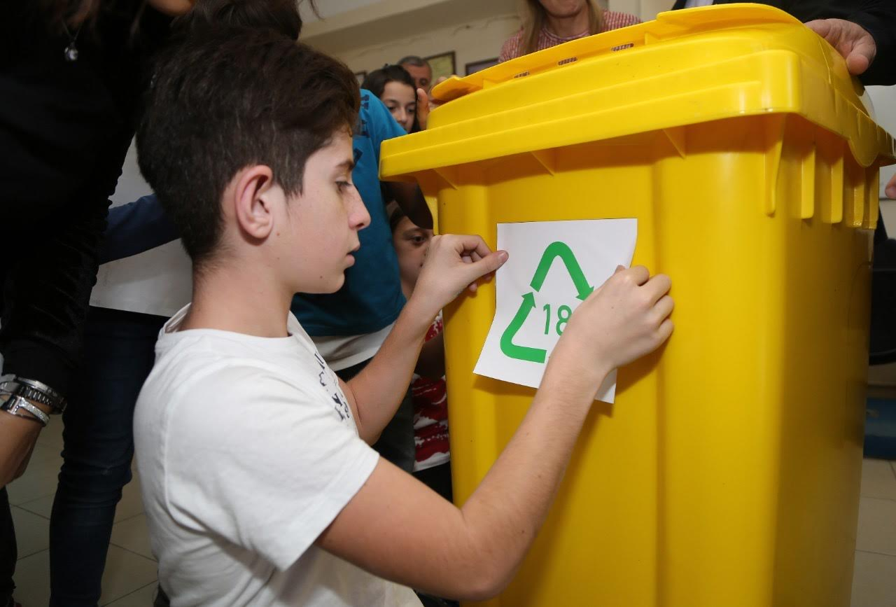
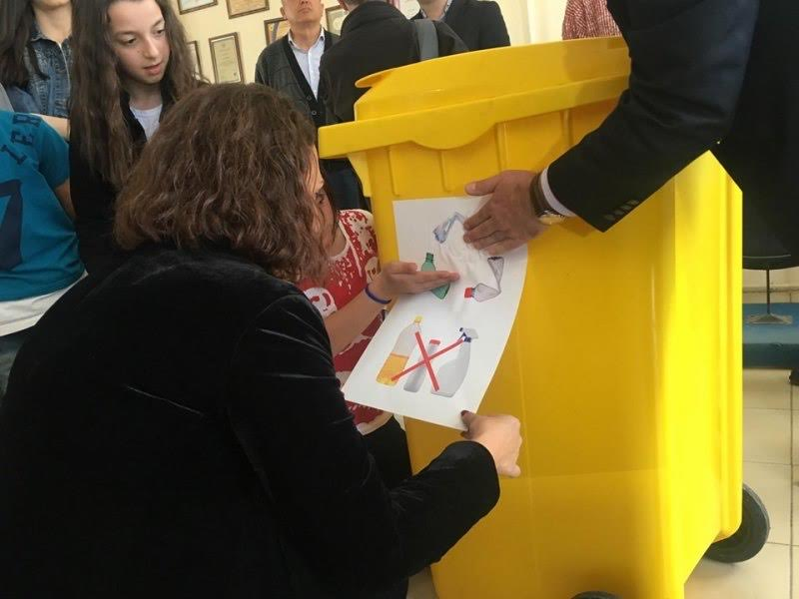 | 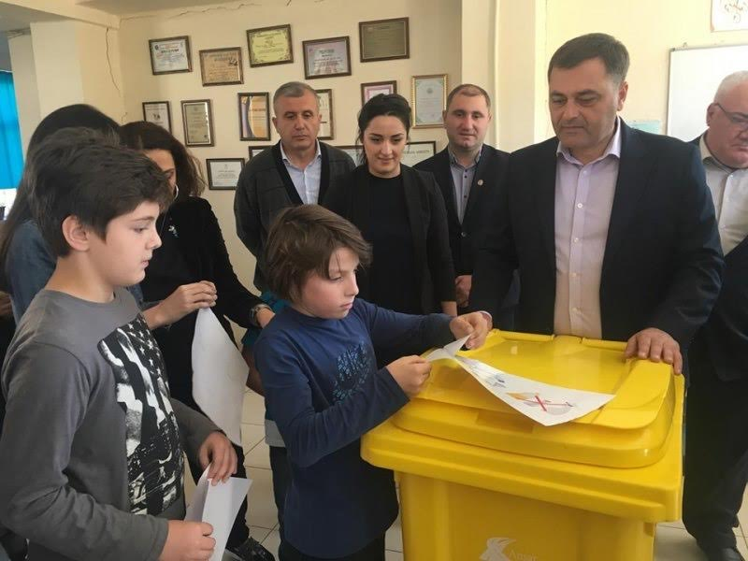
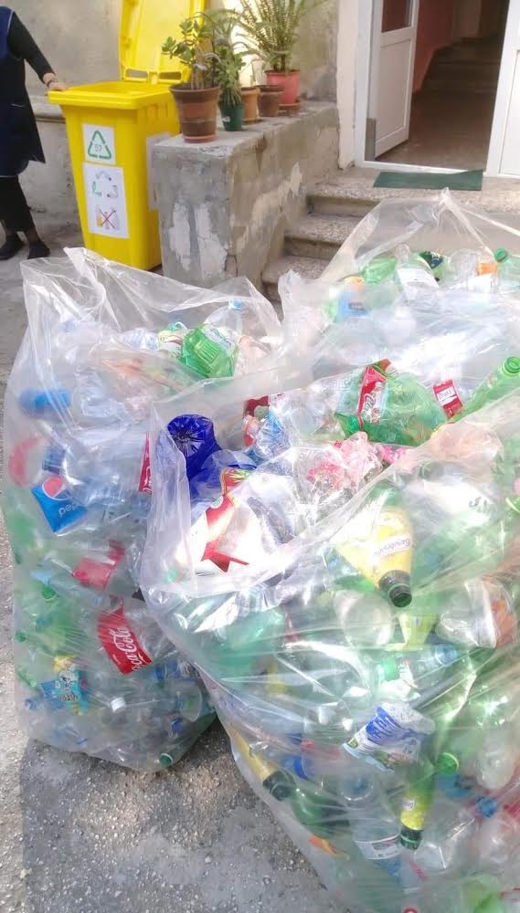 | 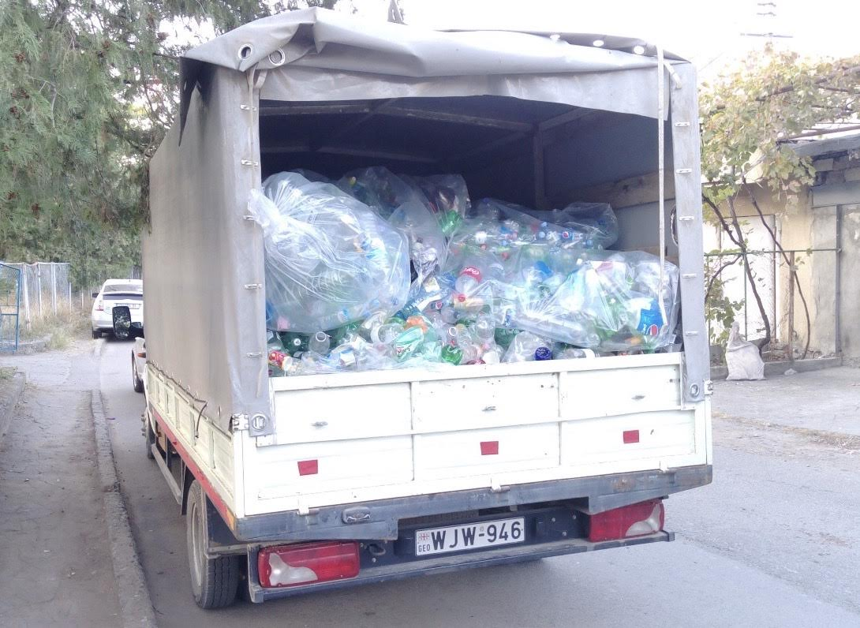

Resolution of the government of Georgia #160, Issued on April 1, 2016

